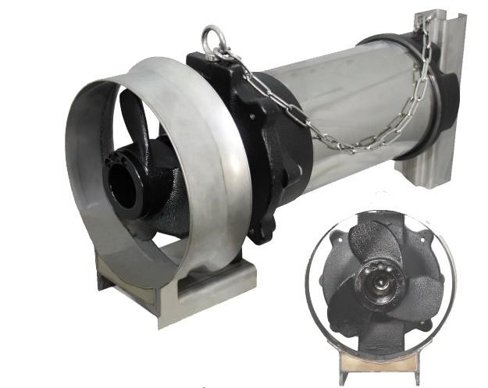

SUBMERSIBLE MIXER

APPLICATION
☆ Wastewater treatment of any industries
☆ River,ponds,lakes dredging
☆ Artificial water flow of amusement facilities
☆ Mix and agitate impurities in the water

MOTOR SPEC
☆ Voltage: 380V - 3phase - 50Hz
☆ Insulation: F
☆ Motor Protection: IP68
☆ Built in motor overload protector
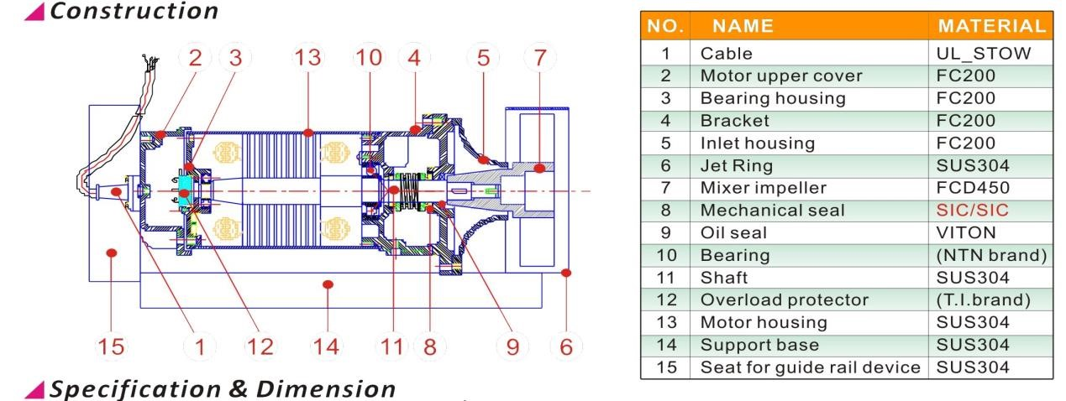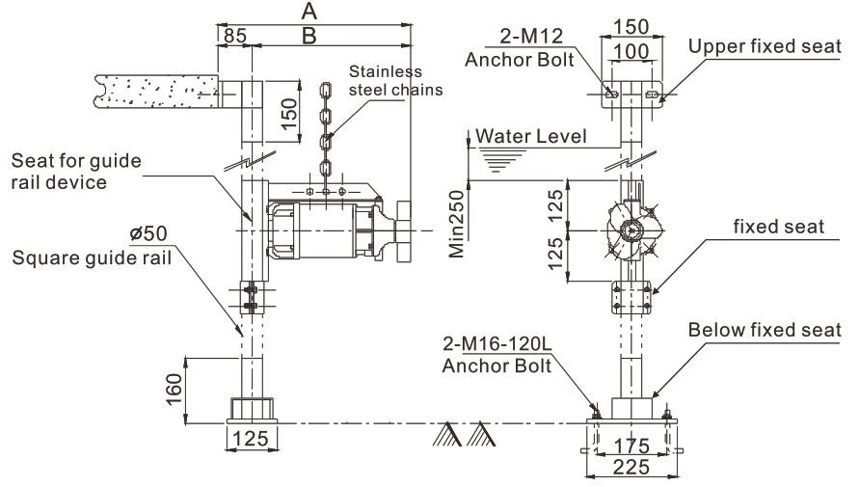

Model | Output |  | Capacity | Flow Speed
Model | KW | HP | M3/h | M/s
MIX-0.4 | 0.4 | 0.55 | 108 | 1.78
MIX-0.75 | 0.75 | 1 | 192 | 2.02
MIX-1.5 | 1.5 | 2 | 270 | 2.5
MIX-2.2 | 2.2 | 3 | 408 | 3.5

